DESIGNING A CERTIFICATE

**Introduction:**

The“CraftingVisuallyAppealingCertificateForaDebateCompetition Using Canva”.Project Focuses on creating Impressive and Memorable Certificates.

**Overviewofthe project:**

InThisProject;FirstofallwecreateEmpathymapaboutthetopicgiven toour team”Designing Visually Appealing Certificate for a Debate Competition Using Canva”.Next We Shoud design Brainstroming map bythe collection of ideas fromour team.by the process of doing this steps we design Certificates.

**PurposeofDesigningavisuallyAppealingCertificate:**

* 1. Creatingawell-designed Certificate can make ap ositive impact on the recipient and the overall impression of the accomplishment.
  2. By using these best design ideas,you can create a certificate that is not only visually appealing but also meaningful and Memorable.

1. **DEFINITIONANDDESIGNINGPROCESS:**

Empathy

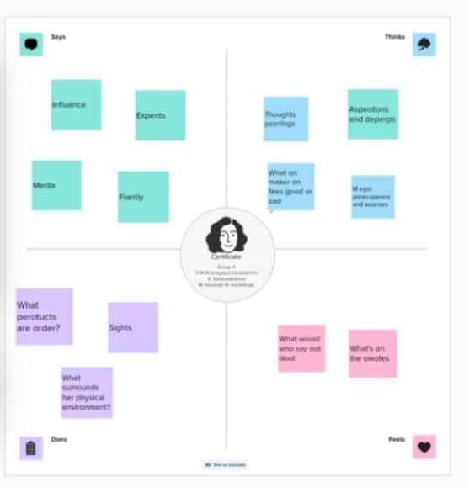

**Brain Stroming:**

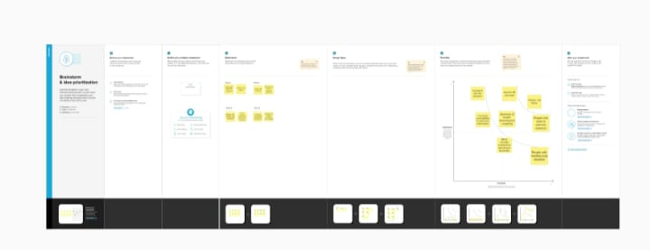

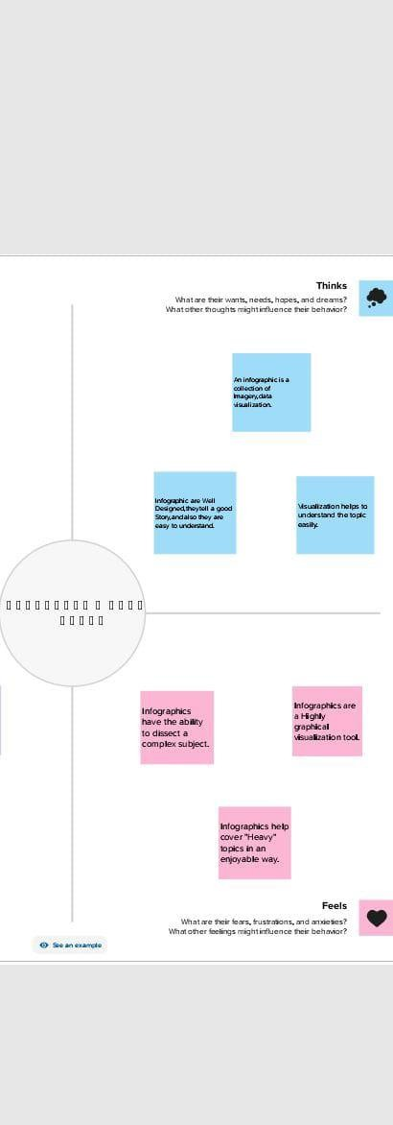

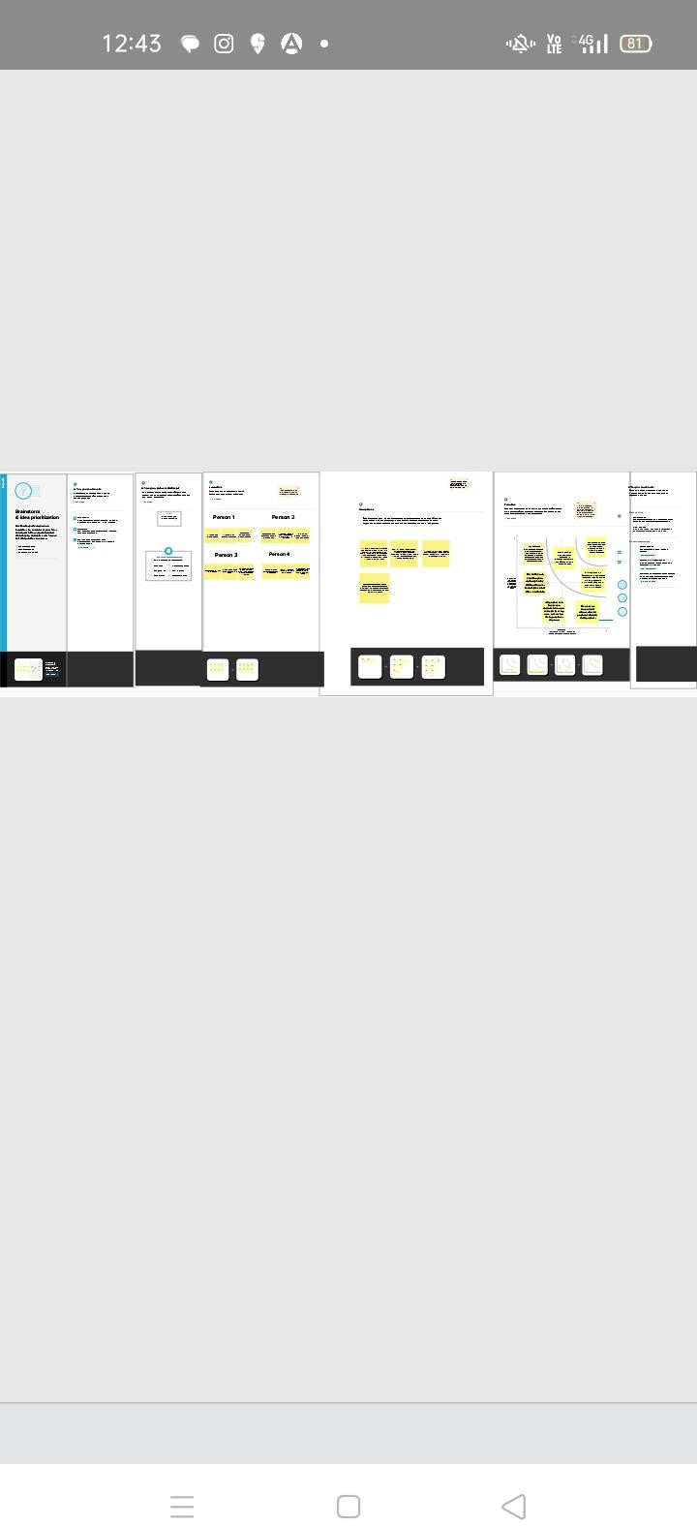

RESULT:

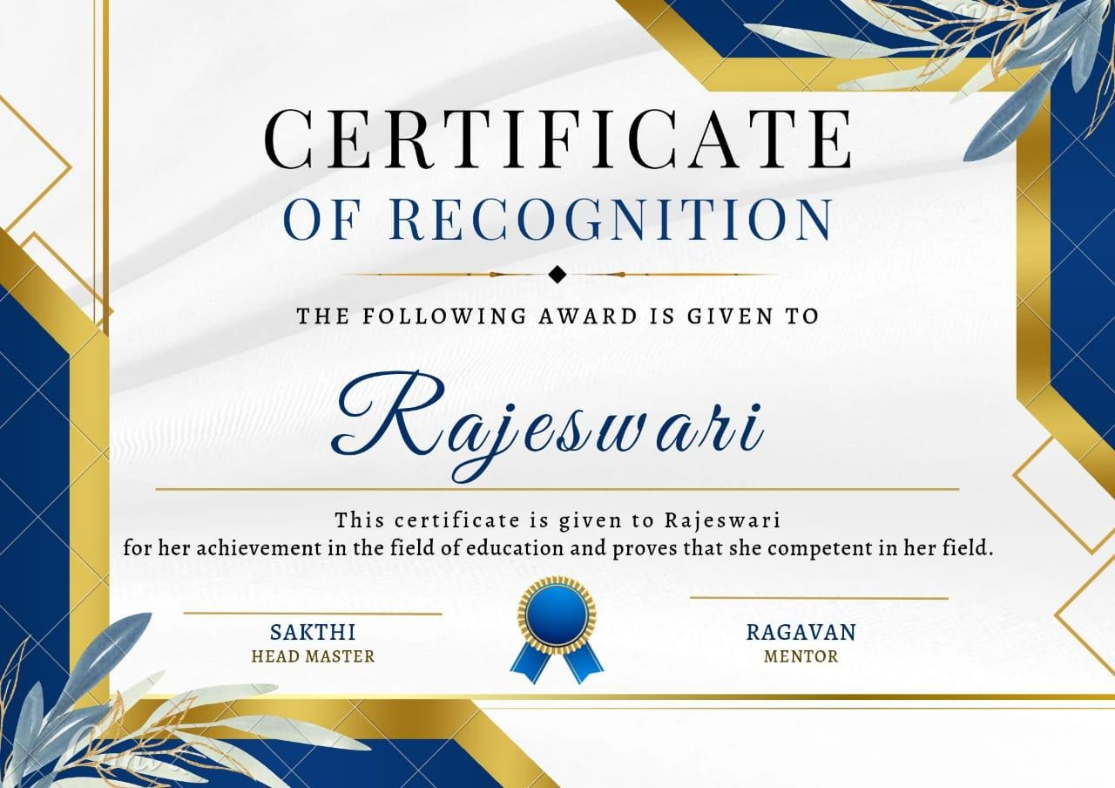

1. ADVANTAGEANDDISADVANTAGE

ADVANTAGE:

*Designingcertificatesbyusingcanvaappiseasyway.

*Canvaisapopularonlinetoolforcreativevisualcontent.

*Canva’scollectionofaward-winningcertificatetemplatesallowsusersto create Attractive certificates without the need for design skills.

*Canvamakescertificatedesigneasy.

*Canvahelpstodesigna certificate.

DISADVANTAGE:

*LimitationonthenumberofTemplates.

*Alignmentconcerns.

*ExportsettingsareLimited.

*Thefreeversionis limited.

*IntellectualpropertyBelongstocanva.

1. APPLICATIONS:

We should use Canva app to design a certificates.It helps us to create a new designsofcertificatesbyownchoice.Canva has manyTemplates.Allcustomcertificatestemplates measure 29.7*21cm or 11*8.5 inches and are optimized for high-quality,full-colour printing.

1. CONCLUSION:

Canvaisanessentialtoolformostbusinesses.SoItplaysamajorroleofcreating

certificatesandAlsocanvahelpstomakedesigningbeautifulcreativeassetseasyforeveryone.